**Bank Loan Query Report**

1. **Summary**

**KPI’s**

**Total Loan Application**

SELECT COUNT(id) AS Total_Applications FROM bank_loan_data



**MTD Loan Application Data**

SELECT COUNT(id) AS Total_Applications FROM bank_loan_data WHERE MONTH(issue_date)= 12



**PMTD Loan Application**

SELECT COUNT(id) AS Total_Applications FROM bank_loan_data WHERE MONTH(issue_date)= 11



**Total Funded Amount**

SELECT SUM(loan_amount)AS Total_Funded_Amount FROM bank_loan_data



**MTD Funded Amount**

SELECT SUM(loan_amount)AS Total_Funded_Amount FROM bank_loan_data

WHERE MONTH(issue_date)= 12



**PMTD Funded Amount**

SELECT SUM(loan_amount)AS Total_Funded_Amount FROM bank_loan_data

WHERE MONTH(issue_date)= 11



**Total Amount Received**

SELECT SUM(total_payment)AS Total_Amount_Collected FROM bank_loan_data



**MTD Total Amount Received**

SELECT SUM(total_payment)AS Total_Amount_Collected FROM bank_loan_data

WHERE MONTH(issue_date)= 12



**PMTD Total Amount Received**

SELECT SUM(total_payment)AS Total_Amount_Collected FROM bank_loan_data

WHERE MONTH(issue_date)= 11



Avg Interest Rate

SELECT AVG(int_rate)*100 AS Avg_Int_Rate FROM bank_loan_data



**MTD AVG Rate**

SELECTAVG(int_rate)*100 AS MTD_Avg_Int_Rate FROM bank_loan_data

WHERE MONTH(issue_date)= 12



**PMTD AVG Interest Rate**

SELECT AVG(int_rate)*100 AS PMTD_Avg_Int_Rate FROM bank_loan_data

WHERE MONTH(issue_date)= 11



**GOOD LOAN ISSUE**

**Good Loan Percentage**

SELECT

(COUNT(CASEWHEN loan_status='Fully Paid' OR loan_status='Current' THEN id END)* 100.0)/

COUNT(id) AS Good_Loan_Percentage

FROM bank_loan_data



**Good Loan Applications**

SELECT COUNT(id)AS Good_Loan_Applications FROM bank_loan_data

WHERE loan_status='Fully Paid' OR loan_status='Current'



**Good Loan Funded Amount**

SELECT SUM(loan_amount)AS Good_Loan_Funded_amount FROM bank_loan_data

WHERE loan_status='Fully Paid' OR loan_status='Current'



**Good Loan Amount Received**

SELECTSUM(total_payment)ASGood_Loan_amount_receivedFROMbank_loan_data

WHEREloan_status='Fully Paid'ORloan_status='Current'



**BAD LOAN ISSUED**

**Bad Loan Percentage**

SELECT

(COUNT(CASEWHEN loan_status='Charged Off' THEN id END)* 100.0)/

COUNT(id) AS Bad_Loan_Percentage

FROM bank_loan_data



**Bad Loan Applications**

SELECT COUNT(id)AS Bad_Loan_Applications FROM bank_loan_data

WHERE loan_status='Charged Off'



**Bad Loan Funded Amount**

SELECT SUM(loan_amount)AS Bad_Loan_Funded_amount FROM bank_loan_data

WHERE loan_status='Charged Off'



**Bad Loan Amount Received**

SELECT SUM(total_payment)AS Bad_Loan_amount_received FROM bank_loan_data

WHERE loan_status='Charged Off'



1. **OVERVIEW**

**MONTH**

SELECT

MONTH(issue_date) AS Month_Munber,

DATENAME(MONTH,issue_date) AS Month_name,

COUNT(id) AS Total_Loan_Applications,

SUM(loan_amount) AS Total_Funded_Amount,

SUM(total_payment)AS Total_Amount_Received

FROM bank_loan_data

GROUPBY MONTH(issue_date), DATENAME(MONTH,issue_date)

ORDERBY MONTH(issue_date)

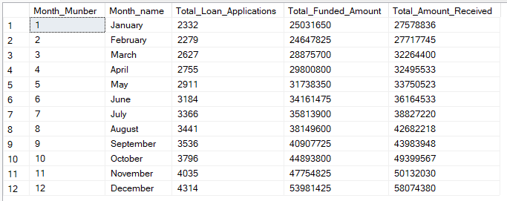

**TERM**

SELECT

term AS Term,

COUNT(id)ASTotal_Loan_Applications,

SUM(loan_amount)ASTotal_Funded_Amount,

SUM(total_payment)ASTotal_Amount_Received

FROMbank_loan_data

GROUPBY term

ORDERBY term

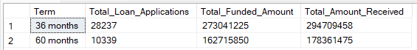

**EMPLOYEE LENGTH**

SELECT

emp_lengthAS Employee_Length,

COUNT(id)ASTotal_Loan_Applications,

SUM(loan_amount)ASTotal_Funded_Amount,

SUM(total_payment)ASTotal_Amount_Received

FROMbank_loan_data

GROUPBYemp_length

ORDERBYemp_length

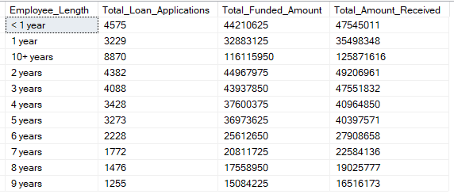

**PURPOSE**

SELECT

purpose AS PURPOSE,

COUNT(id)ASTotal_Loan_Applications,

SUM(loan_amount)ASTotal_Funded_Amount,

SUM(total_payment)ASTotal_Amount_Received

FROMbank_loan_data

GROUPBY purpose

ORDERBY purpose

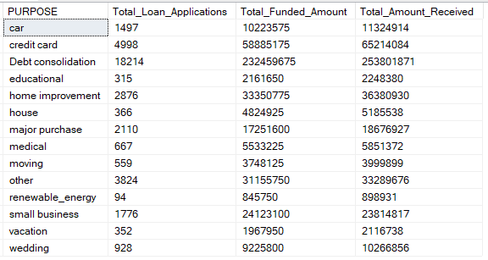

**HOME OWNERSHIP**

SELECT

home_ownershipASHome_Ownership,

COUNT(id)ASTotal_Loan_Applications,

SUM(loan_amount)ASTotal_Funded_Amount,

SUM(total_payment)ASTotal_Amount_Received

FROMbank_loan_data

GROUPBYhome_ownership

ORDERBYhome_ownership

